- Implement MFA on Bucket when users are going to delete any objects, then he needs an Approval from MFA Code.
Ans. 1.Create the bucket and enable the version
2.Enable the MFA in in awd account
3. Create the IAM Policy for MFA Detection:
{
"Version": "2012-10-17",
"Statement": [
{
"Effect": "Deny",
"Action": "s3:DeleteObject",
"Resource": "arn:aws:s3:::your-bucket-name/*",
"Condition": {
"Bool": {
"aws:MultiFactorAuthPresent": false
}
}
},
{
"Effect": "Allow",
"Action": "s3:DeleteObject",
"Resource": "arn:aws:s3:::your-bucket-name/*",
"Condition": {
"Bool": {
"aws:MultiFactorAuthPresent": true
}
}
}
]
}
4.Attach the policy to IAM user.
5.Configure the MFA protection and see the change in the gmail which assign during the MFA authentication.

- Create a Bucket with cli commands & upload the object from cli mode.
Ans. 1. Go to the cloud shell
2 aws s3 ls
3 aws s3 mb s3://demo-bucket-367
4 aws s3 ls
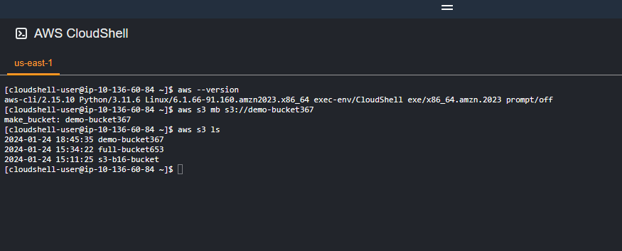 5. After create the bucket use: aws s3 cp file.txt s3://demo-bucket-367
6 data has been successfully upload in the bucket

